Exercise 14
1. Our CEO falls in love with the petite Web Developer. ‘Anamika Pandit’. She now wants her last name to be changed to ‘Sharma’

UPDATE employee_data
SET l_name = 'Sharma'
WHERE f_name = 'Anamika' AND l_name = 'Pandit';
SELECT f_name, l_name, title FROM employee_data WHERE f_name = 'Anamika'; 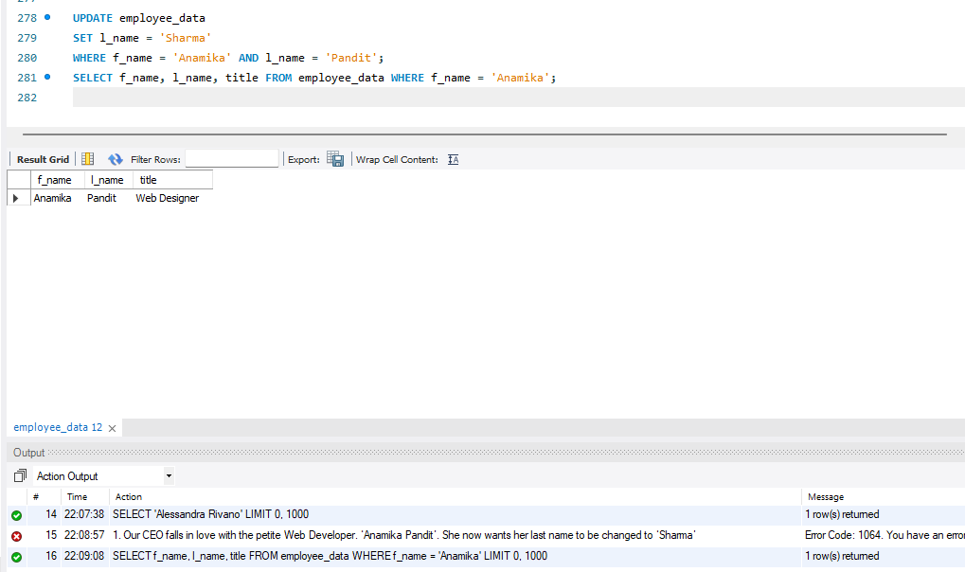

2. All multimedia programmers now want to be called Multimedia Specialist
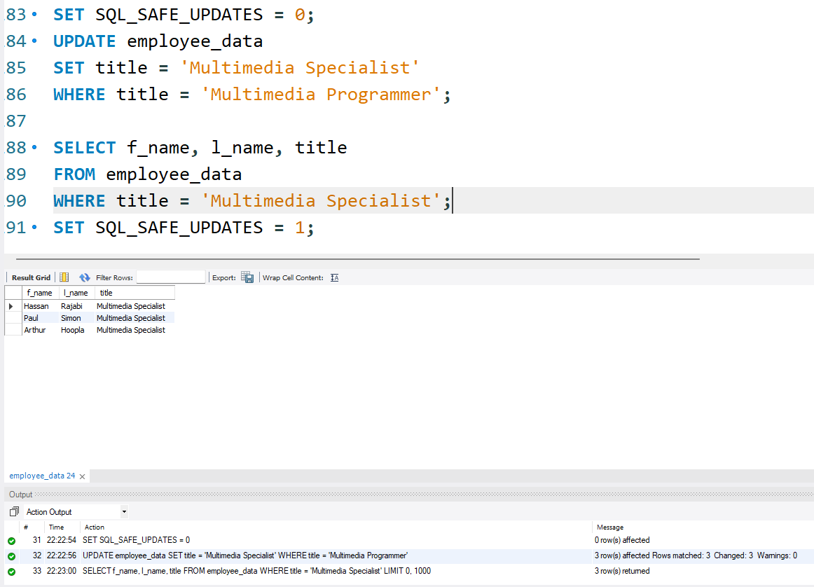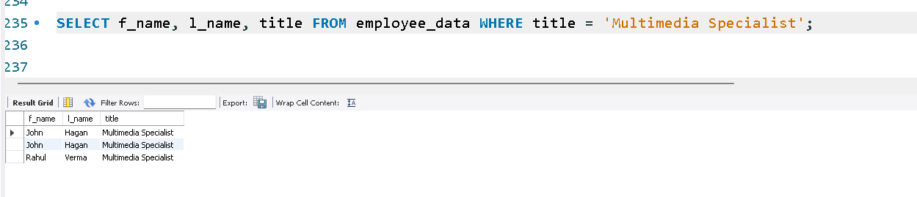
SET SQL_SAFE_UPDATES = 0;
UPDATE employee_data
SET title = 'Multimedia Specialist'
WHERE title = 'Multimedia Programmer';
SELECT f_name, l_name, title
FROM employee_data
WHERE title = 'Multimedia Specialist';
SET SQL_SAFE_UPDATES = 1;
3. After this marriage, the CEO gives everyone a raise. Increase the salaries of all employees (except the CEO) by $10,000.

UPDATE employee_data
SET salary = salary + 10000
WHERE title != 'CEO';
SELECT f_name, l_name, title, salary FROM employee_data;

